Countess Quanta Robot

Developer’s Guide

Brad Pitney

June 25, 2014

Table of Contents

Introduction 4

Overview of the Countess Quanta Robot 4

Hardware Components 6

Upper Body 6

Lower Body 6

Sensors 6

Software Control 8

Controlling the Robot Hardware Components 8

Required Cables 8

Powering on the Robot 11

Controlling the Servo Hardware 11

Controlling the Wheel Hardware 13

Controlling the Kinect Hardware 15

Controlling the Robot with the CountessQuantaControl Software 16

Building and Running the Software 16

Using the Graphical User Interface 16

Hardware Connection Status 17

Connecting to the Wheel Hardware 17

Reinitializing Hardware 17

Log Messages 17

Disabling and Enabling Motion 18

Testing Text-to-Speech 18

Running a Motion Sequence 18

Displaying the Skeleton Viewer 19

Using Speech Recognition 19

Using Gesture Recognition 19

Using Person Tracking 20

Creating and Modifying Motion Sequences 20

Sequence Structure 20

Sequence Examples 22

Understanding and Modifying the CountessQuantaControl Software 24

CountessQuantaControl C# Files and Classes 25

Other Files Used by CountessQuantaControl 26

Adding New XML Elements and Attributes 26

Servo Management 27

Wheel Management 29

Speech Recognition 30

Adding New Speech Recognition Vocabulary 31

Gesture Recognition 32

Adding New Gesture Recognition Vocabulary 32

Person Tracking 33

RobotEyes 34

Error Logging 34

Ideas for Further Development 35

Hardware Development 35

Software Development 38

Motion Sequence Development 44

Appendix 45

Servo Range Data 45

Right Arm Length Measurements 48

Servo Replacement and Hardware Documentation 49

# Introduction

The purpose of this document is to describe the functionality of the Countess Quanta robot and to help new developers in becoming familiar with the robot’s hardware and software systems. This document starts by describing the robot hardware components and the key software features. It then provides instructions on how to connect to the main hardware components individually, using their own development tools. Next, it describes how to build the CountessQuantaControl software and use this to control the robot. The CountessQuantaControl software structure is then discussed, along with how to add new features to the code. Finally, a list of future development tasks is presented, to provide some ideas for future hardware and software work. As the robot is modified and as new features are developed, this document should be updated to include these changes.

Included with this document are several directories:

* **CountessQuantaControl** – Source code of the main control software.
* **ARIA_CSharpWrapper** – Modified ARIA source code for the wheel control.
* **Documentation** – Useful hardware component documentation.
* **Installs** – Programs and development SDKs for the hardware components.
* **PastDevelopment** – Docs, code, videos, etc. from past development work.

# Overview of the Countess Quanta Robot

Countess Quanta is a wheeled, humanoid robot planned to fulfill several roles:

* To interact with humans and provide information about the Portland State University robotics program.
* To act as a guide robot, and show people around the PSU building.
* To participate in the PSU Robot Theater.

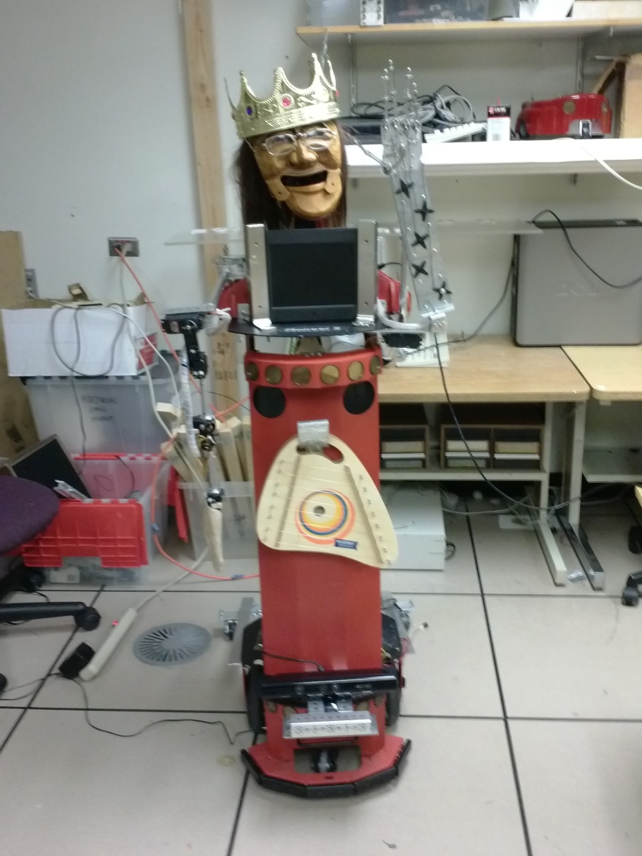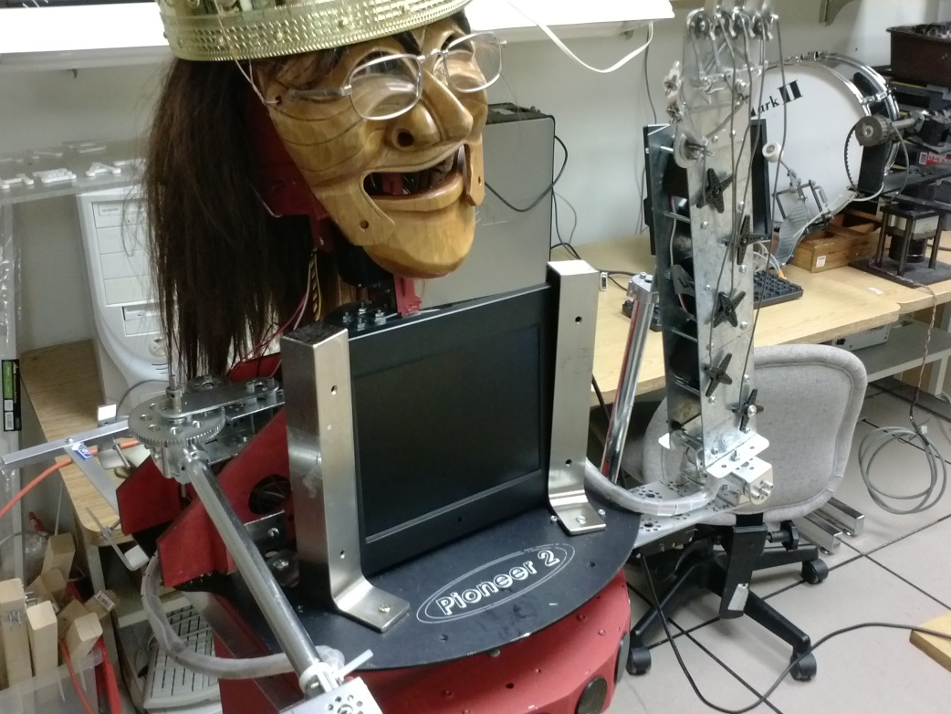

## Hardware Components

### Upper Body

The upper half of Countess Quanta includes two arms and a head animated by a set of 16 servos. These servos are controlled through a Pololu Mini Maestro 18 USB servo controller, which is mounted in the left shoulder of the robot. This device connects through USB to a laptop PC, which sends the servo commands to animate the upper body of the robot. The servo power is supplied from batteries in the robot base, allowing the servos to operate while disconnected from external power.

The right arm is controlled by a series of six servos, which allow the robot to point at objects, wave, and strum the lap harp instrument mounted on the front of the body. The left arm is mounted upright, and uses one servo for waving and five servos for controlling the five fingers. These fingers can curl and extend independently, which allow for more complex hand motions, such as displaying numbers or playing rock-paper-scissors. For the head, one servo turns the head left and right, while another lets the head look up and down. A third servo lets the eyes look left and right, and a fourth servo opens and closes the mouth.

### Lower Body

The lower part of Countess Quanta serves as a wheeled platform on which everything else is mounted. This wheeled base is actually a Pioneer 2 Mobile Robot developed by ActivMedia Robotics. This robot contains three batteries which allow the wheels and upper body servos to operate for several hours when disconnected from external power. A Belkin USB-to-serial adapter is used to connect the Pioneer 2 robot to the laptop PC, which sends motion commands to the wheels. This allows for animations that move and rotate the whole Countess Quanta body, and for turning to face people during interactions. Only a small subset of the full Pioneer 2 capabilities is currently utilized by the control software. The Pioneer 2 provides advanced navigation and sonar sensing capabilities that still need to be integrated into the control system.

### Sensors

The main sensor for Countess Quanta is the Microsoft Xbox 360 Kinect sensor mounted on at the robot’s base:

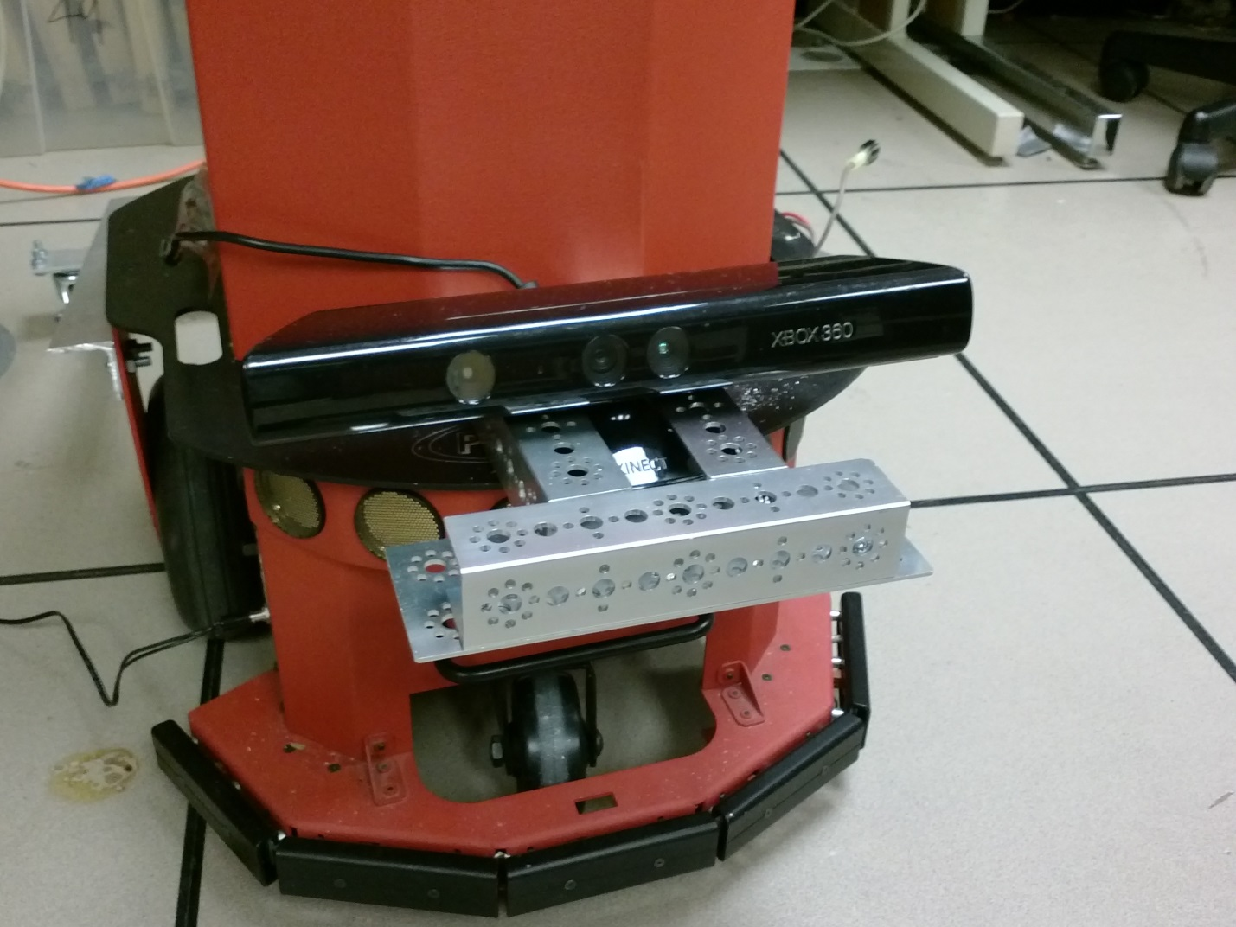

This Kinect communicates with a laptop PC through a USB adapter cable. This adapter cable also provides power to the Kinect through an attached AC power plug, although this currently prevents Countess Quanta from operating on battery power alone. The Kinect device includes a color camera and infrared laser depth sensor for locating objects in 3D space. It also provides a multi-array microphone, which allows for detecting which direction a sound is coming from. Countess Quanta currently uses the Kinect to track the location of people, to detect specific gestures people are making, and to detect spoken commands.

The Pioneer 2 robot provides other sensor systems that are not currently integrated into the control software. The Pioneer 2 provides three sonar arrays which each consist of eight individual sensors (gold-colored circles). Two of these arrays are installed in the front and rear of the Pioneer 2 base, just above the wheels. The third array is located on the front of Countess Quanta’s upper body. This third sonar array is not currently hooked up. The sonars can be used to detect distances between the robot and surrounding obstacles. The Pioneer 2 also provides a set of collision sensors around the edge of the robot, near the ground. These are used to detect physical collisions with objects while moving.

## Software Control

These hardware components are integrated through control software called CountessQuantaControl, which was developed starting in Winter of 2014. CountessQuantaControl is a C# application that uses Windows Presentation Foundation (WPF). It was developed mainly with Visual Studio 2010, and runs under Windows 7 and Windows 8. Here are the main features of this software:

* Configures and manages the servo controller and Pioneer 2.
* Coordinates robot motions as sequences of animation frames.
* Stores move sequences and servo configurations in human-readable xml files.
* Provides speech and gesture recognition through the Kinect.
* Provides person tracking capabilities through the Kinect.
* Provides speech synthesis with animated mouth motion.
* Provides a simple graphical user interface (GUI) for testing and control.
* Provides a versatile error logging system.

# Controlling the Robot Hardware Components

This section provides instructions for how to connect to each of the main hardware components using a Windows laptop PC, and control these devices using their own development software.

## Required Cables

Four cables are required to connect the Countess Quanta hardware components.

1. Power cable for the Pioneer 2 robot. The cable in the lab is labeled with a PeopleBot/GuideBot sticker. Here are the details and a picture:

AU48 - 120 - 120T

Input 120VAC 60Hz

Output 12VDC 1200mA

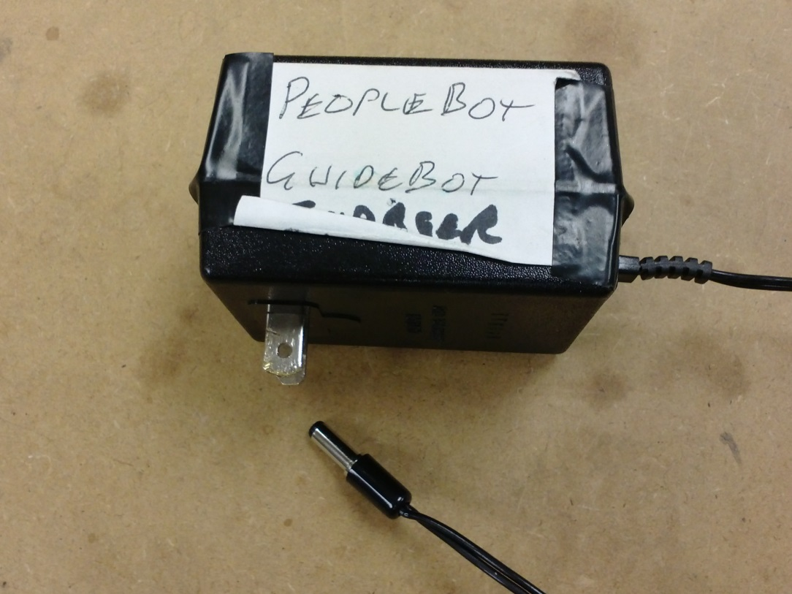

1. A standard ‘USB A Male to Mini-B cable’ is used for connecting the laptop to the servo controller.
2. An RS-232 serial cable and Belkin F5U409 USB-to-serial adapter is used to connect the Pioneer 2 robot to a laptop USB port:

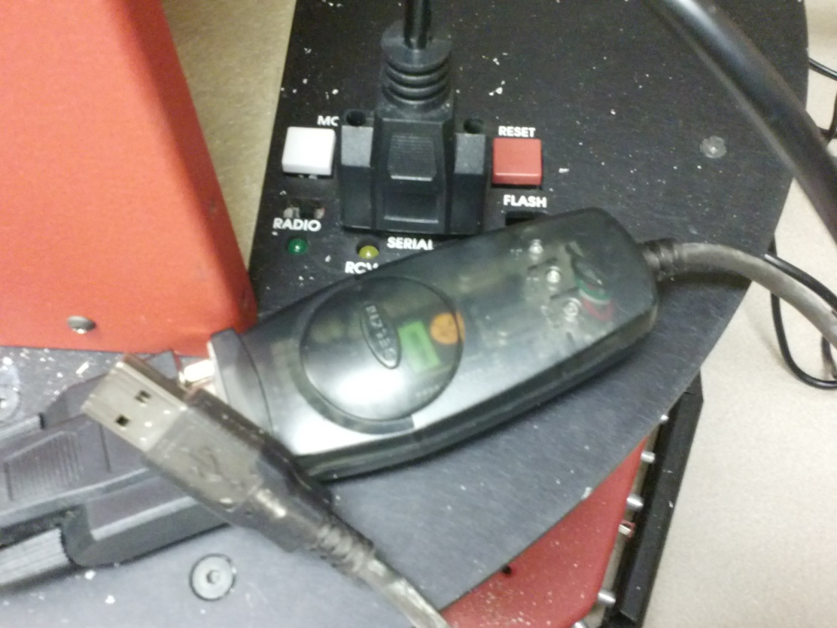

1. An Xbox 360 Kinect adapter cable is used for connecting the Kinect hardware to a laptop USB port. The Xbox Kinect uses a proprietary connector to provide both power and data transfer. This adapter converts this Kinect plug into a separate AC power plug which must be connected to a power outlet, and a standard USB plug which is connected to the laptop PC:

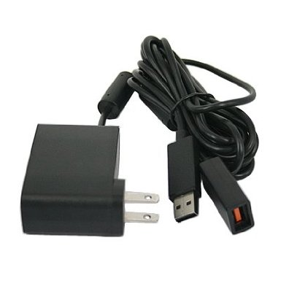

## Powering on the Robot

1. The power switch for the Pioneer 2 is located near Countess Quanta’s right wheel. Switch this on to power up the Pioneer 2 and the servo system. Make sure to switch this off after using the robot, to avoid draining the battery.
2. Just below the power switch is a port for plugging in the power cable. Connect the power cable when possible to avoid draining the battery:

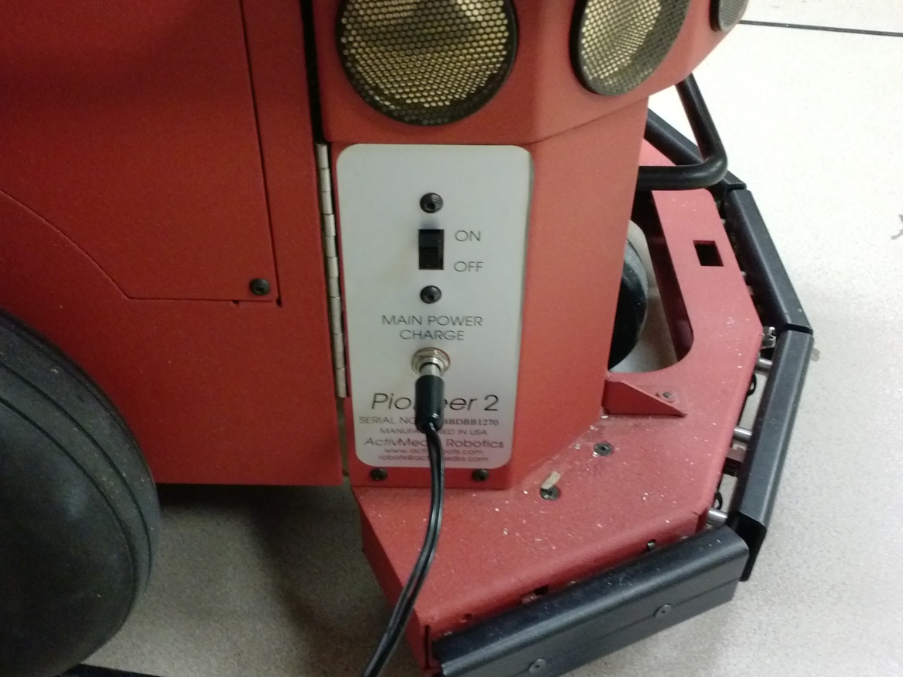

## Controlling the Servo Hardware

1. Power on the robot and use a **USB A Male to Mini-B cable** to connect the laptop PC to the Pololu Mini Maestro servo controller located at the left shoulder of Countess Quanta, as shown:

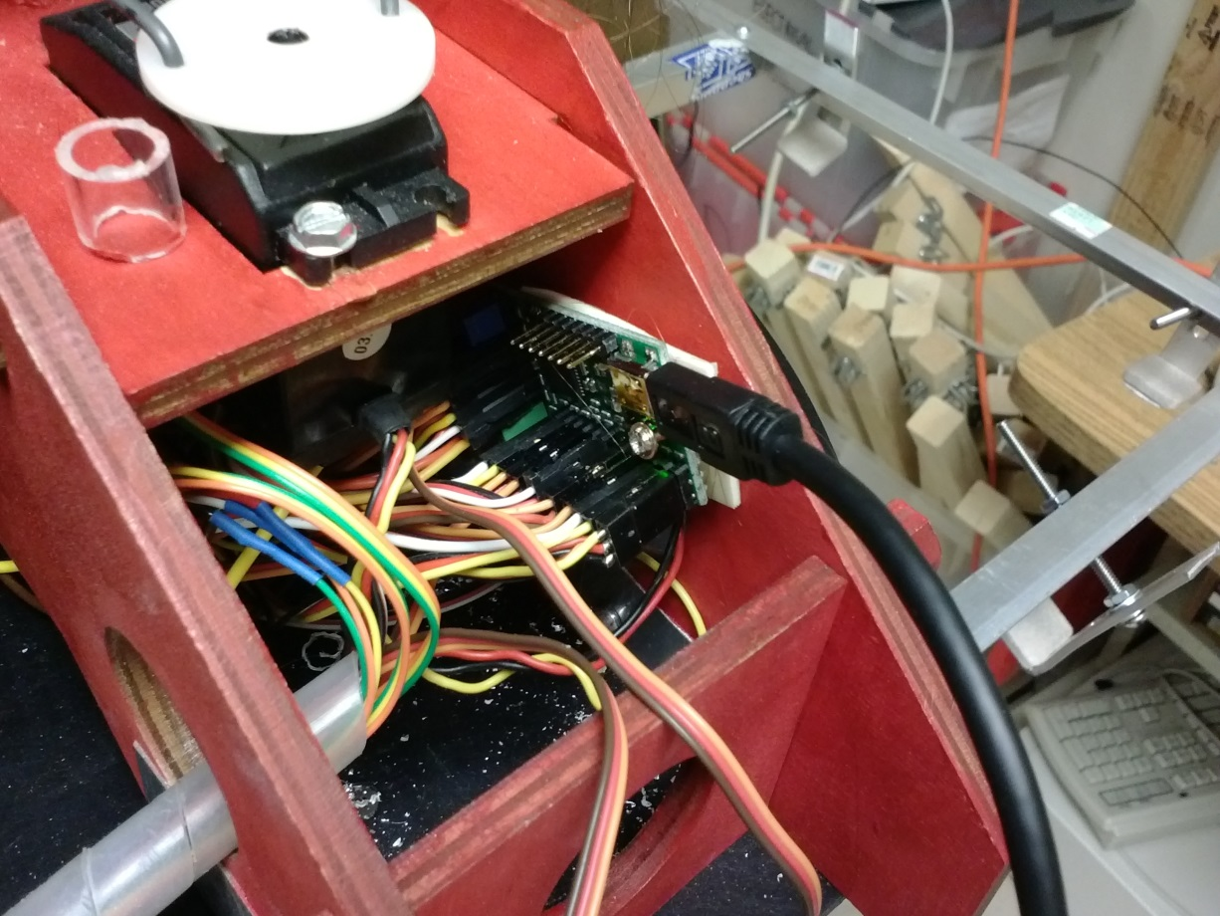

1. In the included **Installs\Servos** directory, unzip **maestro-windows-130422.zip** and run the **setup.exe** program to install the Maestro Control Center application.
2. Run the Maestro Control Center application. If the **Connected To:** box shows **Not Connected**, then use the dropdown to select the servo controller.
3. The Maestro Control Center should show a list of 18 servos (numbered 0 to 17). Currently, 16 of these servos are used in the robot (servos 4 and 7 are not used). To move a servo, click its **Enabled** checkbox to power up the servo, then move the slider to change the servo’s position. To power down a servo, uncheck the **Enabled** checkbox. Below is a list of which servo controls which body part:

Servo 0 - Wrist left/right

Servo 1 - Wrist rotation

Servo 2 - Wrist Up/down

Servo 3 - Arm Up/down

Servo 4 - not used

Servo 5 - Arm rotation

Servo 6 - Shoulder left/right

Servo 7 - not used

Servo 8 - Eyes left/right

Servo 9 - Head up/down

Servo 10 - Head left/right

Servo 11 - Mouth open/close

Servo 12 - Ring finger

Servo 13 - Middle finger

Servo 14 - Pinky finger

Servo 15 - Left arm

Servo 16 - Thumb

Servo 17 - Index finger

## Controlling the Wheel Hardware

1. No official Windows 7 driver exists for the Belkin F5U409 USB-to-serial adapter, but a functional 3rd party driver is included in the **Installs\Pioneer2** directory. To get the Belkin device to work in Windows 7, open this directory and run the **U232-13.2.98.130315.exe** program to install the driver.
2. Power on the robot and connect the serial cable / Belkin adapter from the Pioneer 2 to the laptop. The device should appear in Windows as **Staples Serial On USB Port (COM8)**.
3. In the Windows Start menu, navigate to **Control Panel -> Hardware and Sound -> Devices and Printers**.
4. Right-click on the **Staples Serial On USB Port (COM8)** device and select **Properties**. Select the **Hardware** tab and click the **Properties** button.
5. On the **Port Settings** tab, change the **Bits per second** field to **38400**. The other settings should show 8 data bits, 1 stop bit, no parity, no hardware handshaking. Click **OK** to close these dialogs.
6. In the **Installs\Pioneer2** directory, run the **ARIA-2.7.6.exe** program to install the “ActivMedia Robotics Interface for Applications” software and example code.
7. In **C:\Program Files\MobileRobots\ARIA\examples**, run the **All_Examples** solution for your version of Visual Studio.
8. In this solution, build the **simpleConnect** project. This will build also build the **AriaDLL** project.
9. Open a command prompt and navigate to **C:\Program Files\MobileRobots\ARIA\bin**. Run the **simpleConnect** application with the following command (if the Belkin adapter was assigned to a different COM port, you will need to substitute **COM8** for the correct COM port number):

**simpleConnect.DebugVC10.exe -rp COM8**

1. If the simpleConnect application was able to communicate with the Pioneer 2 robot, it should return something like the following:

Could not connect to simulator, connecting to robot through serial port COM8.

Syncing 0

Syncing 1

Syncing 2

Connected to robot.

Name: AM_PeopleBot

Type: Pioneer

Subtype: p2pb

Loaded robot parameters from p2pb.p

simpleConnect: Connected.

simpleConnect: Pose=(0.00,0.00,0.00), Trans. Vel=0.00, Battery=13.40V

simpleConnect: Sleeping for 3 seconds...

simpleConnect: Ending robot thread...

Disconnecting from robot.

simpleConnect: Exiting.

If simpleConnect is able to communicate with the Pioneer 2, then CountessQuantaControl should be able to as well.

## Controlling the Kinect Hardware

1. Connect the Xbox 360 Kinect adapter cable to the Kinect and the laptop USB port. On the adapter cable, connect the AC power plug into an outlet to power up the Kinect.
2. In **Installs\Kinect**, run **KinectSDK-v1.8-Setup.exe** to install the Kinect SDK.
3. In **Installs\Kinect**, run **KinectDeveloperToolkit-v1.8.0-Setup.ex**e to install the Kinect Developer Toolkit.
4. In the Windows Start menu, click **Kinect for Windows SDK v1.8 -> Developer Toolkit Browser v1.8.0 (Kinect for Windows)** to run the Toolkit Browser.
5. The Toolkit Browser contains many example programs that demonstrate the features of the Kinect. Scroll down to **Skeleton Basics-WPF** and click **Run** to start this program.
6. This should connect to the Kinect hardware and display a black window. Stand in front of the Kinect to appear on the display as a skeleton visualization. This skeleton functionality is used in the CountessQuantaControl software for person tracking and gesture recognition.

# Controlling the Robot with the CountessQuantaControl Software

This section describes how to control the entire robot, using the CountessQuantaControl software. It covers how to use the GUI, how to test the different robot features, and how to understand and create motion sequences.

## Building and Running the Software

In the **CountessQuantaControl** directory, run the CountessQuantaControl solution. You may need to create a new solution to use this project with a different version of Visual Studio (e.g. CountessQuantaControl-vs2012.sln). Build the CountessQuantaControl project and run this application.

## Using the Graphical User Interface

This program will display the CountessQuantaControl GUI, which is used to display the hardware connection status and test various aspects of the system:

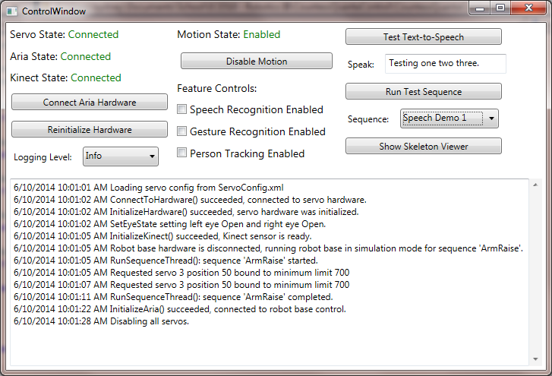

### Hardware Connection Status

The left side of the form shows the connection status of the Countess Quanta servos, wheels, and Kinect hardware. When the software is started, the **Servo Status** and **Kinect Status** fields should show **Connected**, while the **Wheel Status** will show **Not Connected**.

### Connecting to the Wheel Hardware

Due to an issue with how the CountessQuantaControl program currently connects to the ARIA software, the application will freeze if it tries to connect while the Pioneer 2 hardware is not connected to the laptop. The **Connect Wheel Hardware** button was added to work around this issue. After the Pioneer 2 hardware has been connected, click this button to connect; the **Wheel Status** field should then show **Connected**.

Note that if the Belkin adapter is using a different COM port than COM8, then this will need to be changed in the modified **AriaDebugVC10.dll** that the CountessQuantaControl project uses to communicate with the Pioneer 2. To do this, open the **AriaDLL** project included with CountessQuantaControl and modify the **InitializeRobot_dll()** function so that the **builder.add("-rp COM8")** call uses the correct COM port. Then rebuild the **AriaDebugVC10.dll**, copy this dll into the **CountessQuantaControl\bin\Debug** directory (replacing the existing dll), and restart the CountessQuantaControl. The **Connect Wheel Hardware** button should then work correctly.

### Reinitializing Hardware

The **Reinitialize Hardware** button attempts to reconnect to the hardware devices if they are unplugged from the laptop and then plugged back in, or powered off and back on, while the CountessQuantaControl software is running.

### Log Messages

The bottom half of the CountessQuantaControl consists of a logging window that displays errors and other messages. The **Logging Level** dropdown allows you to select what kind of log messages will be displayed, depending on the messages’ severity:

**Error** – This displays only messages that indicate a problem in the system.

**Warning** – This displays warnings messages that indicate unusual behavior. Error messages are also displayed.

**Info** – This displays extra information regarding what the system is doing. Warning and Error messages are also displayed.

**Debug** – This displays all messages, including detailed information used in software debugging. This is the most detailed logging, but will also fill up the screen with many messages.

### Disabling and Enabling Motion

The **Disable Motion** button can be clicked to stop all servo and wheel motion, and disallow new motions. Clicking the button again (now displaying **Enable Motion**) will allow the robot to move again. The **Motion State** field will show whether the motion state is currently **Enabled** or **Disabled**. This feature can be used to terminate motion during a motion sequence and put the system in a relatively safe state. Note that the robot should be powered down using the power switch to put it in a truly safe state, before making adjustments that would be harmful if the robot were to move (e.g. putting your fingers between gears, etc.).

### Testing Text-to-Speech

The **Test Text-to-Speech** button can be clicked to test the speech synthesizer. The system will speak whatever phrase is entered in the **Speak** field. This feature can be useful in testing the sound and duration of spoken phrases, before these are added to a motion sequence.

### Running a Motion Sequence

Robot motion sequences are stored in XML format under **CountessQuantaControl\bin\Debug**, in the **SequenceFile.xml** file. To run a motion sequence from this file, the name of the sequence is selected from the **Sequence** dropdown box. The **Run Motion Sequence** button can then be clicked to perform the motion sequence. This can be useful for testing the actual robot motion when developing a new motion sequence. Note that this file contains many test sequences from various phases of development, and some motions may not be very functional at this point. Some simple sequences to try are the **Speech Demo 1**, **2**, and **3** sequences, which show robot mouth motion during speech synthesis. The **Wheel Motion Demo** shows some simple forward/back and rotation moves using the wheels. Creation of new motion sequences is discussed later in this section.

### Displaying the Skeleton Viewer

Clicking Show Skeleton Viewer button opens a black display screen similar to the **Skeleton Basics-WPF** program from the Kinect Developer Toolkit. Standing in front of the Kinect should show a skeleton visualization on the display.

### Using Speech Recognition

Checking the **Speech Recognition Enabled** checkbox activates the speech recognition feature, which uses the Kinect microphone to detect spoken commands. When a phrase is recognized, the system runs a corresponding motion sequence in response. The phrases that can be recognized are stored in SpeechGrammer.xml, which is discussed in a later section. Here are some simple examples:

Say “Hello” – Countess will say hello and wave her left hand.

Say “How are you doing?” – Countess will respond.

Say “Can you introduce yourself?” – Countess will introduce herself.

### Using Gesture Recognition

Checking the **Gesture Recognition Enabled** checkbox activates the gesture recognition feature, which uses the Kinect skeleton visualization to detect specific gestures performed by the user. The gestures that can be recognized are stored in KinectManager.cs, which is discussed in a later section. To use this feature, you must stand in front of the Kinect and try to stand far enough away that your whole skeleton is visible in the Skeleton Viewer. Here are some example gestures:

Raise your right hand above your head – Countess will say hello and wave her left hand.

Place your right hand on your stomach – Countess will play her instrument.

Walk towards Countess (within 1.5 meters) – Countess will react accordingly.

### Using Person Tracking

Checking the Person Tracking Enabled checkbox activates the person tracking feature, which uses the Kinect skeleton visualization to detect the position of the user and turns the robot to face the user. To use this feature, you must stand in front of the Kinect and try to stand far enough away that your whole skeleton is visible in the Skeleton Viewer. Move back and forth in front of Countess and she should turn to face you.

## Creating and Modifying Motion Sequences

Robot motion sequences are stored in XML format, which allows for creating and modifying sequences without needing to change any source code. All motion sequences are stored in the **SequenceFile.xml** file, which is in the **CountessQuantaControl\bin\Debug** directory. Motion sequences can be added to this file and then easily tested using the **Run Motion Sequence** button on the GUI.

### Sequence Structure

Sequences are represented by a structure of XML elements, which may each contain XML attributes. Here is a description of the XML elements and their attributes, which are used to define Sequences:

* **ServoPosition** – This element represents the movement of a single servo to a specified target position.
  + **Index** – This attribute identifies which servo should move. This matches the servo number used in the Maestro Control Center application.
  + **Position** – This is the position that the servo should move to. This is equivalent to the positions used in the Maestro Control Center application.
* **WheelMove** – This element represents the movement of the Pioneer 2 wheels.
  + **Translation** – This attribute sets how far forwards or backwards the robot should move (in millimeters).
  + **Rotation –** This sets how much the robot should turn left or right (in degrees).
  + **LeftWheel –** This sets how far forwards or backwards the robot’s left wheel should move (in millimeters).
  + **RightWheel –** This sets how far forwards or backwards the robot’s right wheel should move (in millimeters).

Note that a Translation move and a Rotation move can be used together, for example, to have the robot move forward while also turning to the right. Similarly, a LeftWheel move and RightWheel move can be used together, to move both wheels simultaneously. However, Translation/Rotation moves cannot be used together with LeftWheel/RightWheel moves, in the same WheelMove element.

* **Frame** – This element represents a single ‘animation frame’ of the robot. A Frame may contain a set of ServoPosition elements; one for each servo that should be moved to a new position. It may also contain a WheelPosition element to move the Pioneer 2 wheels. Several attributes are available as well:
  + **TimeToDestination** – This specifies how long it should take for the wheels and servos to move to their new positions. The wheels and each servo automatically scales their speed based on how far they needs to move, so that the wheels and all servos in a Frame reach their new positions at the same time.
  + **Speech** – This is used to set a phrase that the robot will speak with the speech synthesizer, when the Frame runs. This speech is asynchronous, so the sequence will continue running while the robot speaks.
  + **Delay** – If a delay is set, then the sequence will stop and wait for the specified amount of time (in seconds), before continuing on to the next Frame.
  + **EyeState** – This controls the state of the robot eye LEDs (once this hardware is hooked up). This can be set to “Open”, “Closed”, “LeftClosed”, or “RightClosed”.
  + **Name** – This gives the Frame a name, which can sometimes be useful for identifying a Frame in the log messages.
* **Sequence** – This element consists of an ordered list of Frames. When a Sequence is performed, each Frame is processed in turn. Once a Frame has completed its motion, the Sequence continues on to the next Frame until all Frames in the sequence have executed.
  + **Name** – The name of the Sequence should be set to something that identifies its purpose or behavior. The name is used in the software, when selecting which Sequence to run.

### Sequence Examples

It may be easier to describe the Sequence format by looking at some examples.

<Sequence Name="Example Sequence">

<Frame TimeToDestination="1">

<ServoPosition Index="0" Position="800" />

<ServoPosition Index="1" Position="1200" />

</Frame>

<Frame TimeToDestination="0.5">

<ServoPosition Index="0" Position="2200" />

<ServoPosition Index="1" Position="1000" />

</Frame>

</Sequence>

All Sequences have a ‘Name’ attribute, which is set to “Example Sequence”, in this instance. When running a Sequence, the Sequence ‘Name’ is used to specify which Sequence in the SequenceList.xml file should be performed. In this example, the Sequence contains two Frames, which in turn each contain two ServoPositions. When this Sequence is executed, the first Frame will be processed and will move Servo 0 to position 800 and Servo 1 to position 1200. The servo speeds will be set automatically so that both servos arrive at their respective positions after 1 second, as specified by the Frame’s ‘TimeToDestination’ parameter. Once these servos arrive at their destinations, the second Frame will be processed and will move Servo 0 to position 2200 and Servo 1 to position 1000. The servo speeds will be set to reach these positions in 0.5 seconds, as specified by the second Frame’s ‘TimeToDestination’ parameter. Once the servos reach these positions, the Sequence will be complete.

The Frame object also has several additional attributes that can be used to provide some extra functionality. One is the ‘Delay’ attribute, which causes the Sequence to wait for some amount of time before proceeding to the next Frame. Another is the ‘Speech’ attribute, which causes the speech synthesizer to begin speaking the specified text. The speech synthesizer runs asynchronously, so the Sequence can continue on to processing the next Frame while the synthesizer is speaking. This allows for servo/wheel motions, while the robot is speaking. Both the ‘Delay’ and ‘Speech’ attributes can be used with Frames that contain no ServoPosition or WheelMove elements, to allow for delay or speech behavior without motion. Here is a modified version of the first example, with some extra ‘Delay’ and ‘Speech’ Frames:

<Sequence Name="Example Sequence 2">

<Frame TimeToDestination="1">

<ServoPosition Index="0" Position="800" />

<ServoPosition Index="1" Position="1200" />

</Frame>

<Frame Delay="2"/>

<Frame Speech="Testing one two three."/>

<Frame TimeToDestination="0.5">

<ServoPosition Index="0" Position="2200" />

<ServoPosition Index="1" Position="1000" />

</Frame>

</Sequence>

This example Sequence contains four frames, but the first and fourth frames are identical to be previous example. When running this Sequence, the first Frame will be processed as before, with Servos 0 and 1 moving to their respective positions. Once this movement completes, the second Frame will be processed and the Delay=“2” attribute will cause the Sequence to pause for 2 seconds. After these 2 seconds, the third Frame will be processed, and the ‘Speech’ attribute will cause the speech synthesizer to start speaking the selected phrase “Testing one two three.” The speech synthesizer runs asynchronously, so as soon as the synthesizer starts speaking, the fourth Frame will be processed. This Frame performs the second servo move, with Servos 0 and 1 moving to their final position. The speech synthesizer will keep talking during this motion and after the Sequence has completed.

A Frame can also contain multiple attributes, as in the following example:

<Sequence Name="Example Sequence 3">

<Frame TimeToDestination="1" Delay="2" Speech="Hello!">

<ServoPosition Index="0" Position="800" />

<ServoPosition Index="1" Position="1200" />

</Frame>

</Sequence>

In this example, the Frame has ServoPositions and both a ‘Delay’ and ‘Speech’ attribute. In this case, the Speech will be processed first, causing the robot to begin saying “Hello!” Right after this speech starts, the Delay will be processed and the Sequence will pause for 2 seconds (while the speech continues). After this 2 second delay, the robot motion will be processed, and Servos 0 and 1 will move to their respective positions, which will take 1 second.

Here is an example that shows the different ways that the WheelMove element can be used:

<Sequence Name="Example Sequence 4">

<Frame TimeToDestination="1">

<WheelMove Translation="100" />

</Frame>

<Frame TimeToDestination="1">

<WheelMove Rotation="45" />

</Frame>

<Frame TimeToDestination="1">

<WheelMove Translation="-200" Rotation="-90" />

</Frame>

<Frame TimeToDestination="1">

<WheelMove LeftWheel="100" />

</Frame>

<Frame TimeToDestination="1">

<WheelMove RightWheel="100" />

</Frame>

<Frame TimeToDestination="1">

<WheelMove LeftWheel="-50" RightWheel="-20" />

</Frame>

</Sequence>

The robot will first move forward 100 mm over a period of 1 second. It will then spend the next second rotating 45 degrees to the left (counterclockwise). During the third frame, it will combine two moves by moving backwards 200 mm while simultaneously turning 90 degrees to the right (clockwise). In the fourth frame, the robot will move only its left wheel 100 mm forward. In the following frame, it will move the right wheel 100 mm forward. During the last frame, the robot will move both wheels simultaneously, by moving the left wheel backwards 50 mm and the right wheel backwards 20 mm.

# Understanding and Modifying the CountessQuantaControl Software

This section describes the source code files and class structure of the CountessQuantaControl project, how the main software features work, and how to add new speech and gesture recognition vocabulary.

## CountessQuantaControl C# Files and Classes

**ControlWindow.xaml** – This file contains the XAML code that defines the main CountessQuantaControl GUI window.

**ControlWindow.xaml.cs** – Creates and initializes all of the main object used in the project, in the ControlWindow() method. Also contains logic for the GUI.

**SkeletonViewer.xaml** – Contains the XAML code that defines the SkeletonViewer window. This code is based on the ‘Skeleton Basics-WPF’ application from the Kinect Toolkit.

**SkeletonViewer.xaml.cs** – Contains the implementation for the SkeletonViewer window. This code is based on the ‘Skeleton Basics-WPF’ application from the Kinect Toolkit.

**ServoManager.cs** – Contains the ServoManager class, which connects to the Pololu servo controller through Usc.dll. Defines the Servo class to track the status of each servo, loads the servo configuration from the ServoConfig.xml file, and handles the process of servo motion.

**AriaManager.cs** – Contains the AriaManager class, which connects to the modified ARIA dll and handles the wheel motion of the Pioneer 2.

**RobotSpeech.cs** – Contains the RobotSpeech class, which handles speech synthesis commands and moves the robot’s mouth (using ServoManager) while speech is being performed.

**RobotEyes.cs** – Contains the RobotEyes class, which handles control of the LED eyes (once this hardware is connected). Provides methods for opening and closing one or both eyes (turning the LEDs on and off), and provides automated blinking.

**PersonTracking.cs** – Contains the PersonTracking class, which takes skeleton position updates from the Kinect and turns the robot to face the user. It can have the robot turn its head, eyes, or whole body by sending commands to the servos/wheels through the ServoManager and AriaManager.

**SequenceProcessor.cs** – Contains the SequenceProcessor class, which handles the process of running robot motion sequences. It loads the SequenceList.xml file and executes the selected sequence using the ServoManager, AriaManager, and RobotEyes classes.

**SequenceClasses.cs** – Contains classes used primarily by the SequenceProcessor. These are the ServoPosition, WheelMove, Frame, Sequence, and SequenceList classes. These classes mainly store data that is read from the SequenceList.xml file.

**KinectManager.cs** – Contains the KinectManager class, which handles connection to the Kinect hardware. It implements the speech and gesture recognition functionality by detecting the speech/gesture and running the corresponding response sequence using SequenceProcessor. It also updates PersonTracking with skeleton position data. Most of this code is adapted from the ‘Skeleton Basics-WPF’ and ‘Speech Basics-WPF’ code from the Kinect Toolkit.

**ErrorLogging.cs** – Contains the ErrorLogging class, which is used to log various messages from the software and display these as text on the main GUI. ErrorLogging is a public static class, so every class in the project can add log messages without needing to explicitly include this class.

## Other Files Used by CountessQuantaControl

**SequenceFile.xml** – This file contains all of the robot motion sequences.

**ServoConfig.xml** – Contains configuration data for each servo, such as position limits.

**SpeechGrammar.xml** – Contains speech recognition vocabulary data.

**AriaDebugVC10.dll** – This dll is used to send motion commands to the Pioneer 2 wheels.

**Usc.dll** – Used to send motion commands to the Pololu servo controller.

**UsbWrapper.dll** – Required for Usc.dll.

## Adding New XML Elements and Attributes

As new kinds of hardware are added to Countess Quanta, it may be useful to integrate these into the sequence-based control system. To do this, modify the SequenceClasses.cs file to add the new control to the Frame class, using the existing items as examples. The existing implementation uses .NET Attribute syntax to automatically handle how these parameters are loaded from an XML file. Simple controls that require a single parameter, such as ‘Delay’ and ‘Speech’, can be added to the Frame as an XmlAttribute. Controls that require multiple parameters, such as ‘WheelMove’, can be added as a new class containing each parameter as a separate XmlAttribute. This class can then be added to Frame as an XmlElement. The new parameters can then be used in a sequence in SequenceList.xml, and the software should automatically populate the new Frame items when this sequence is loaded.

In SequenceProcessor.cs, the RunSequenceThread() method will need to be modified to use these new parameters. This method contains a loop that steps through each frame in the sequence and makes the appropriate calls to the hardware components. For new hardware, support would need to be added either be added to an existing class, or added within a new type of class. The communication methods could then be called within this RunSequenceThread method to use them during sequence execution.

## Servo Management

Commands to control the Pololu Mini Maestro servo controller hardware are handled by the ServoManager class, which is implemented in the ServoManager.cs file. Initialization and control of the hardware is performed using the Pololu C# library, which is part of the Pololu USB SDK. This SDK is available in **pololu-usb-sdk-120712.zip**, which is in the included **Installs\Servos** directory. The **CountessQuantaControl\bin\Debug** directory contains the **Usc.dll** and **UsbWrapper.dll** files, which were built from the unmodified Usc C# project included in this Pololu SDK (in **pololu-usb-sdk\Maestro**).

To better manage each of the 16 servos that are currently used in the robot, ServoManager stores settings and polled hardware data for each of these servos by using the ‘Servo’ class. On software startup, ServoManager reads in the settings for each servo from an xml file called ‘ServoConfig.xml’, which is stored in the **CountessQuantaControl\bin\Debug** directory. Here is an example entry for one of the servos:

<Servo>

<index>0</index>

<name>Wrist left/right</name>

<positionLimitMin>700</positionLimitMin>

<positionLimitMax>2300</positionLimitMax>

<speedLimitMin>10</speedLimitMin>

<speedLimitMax>1000</speedLimitMax>

<defaultPosition>1400</defaultPosition>

<defaultSpeed>20</defaultSpeed>

<defaultAcceleration>0</defaultAcceleration>

</Servo>

Here is an overview of what each of these parameters represents:

**index** – The index number that identifies this particular servo in the Maestro servo controller.

**name** – A human readable name that describes which servo this is in the robot.

**positionLimitMin** – The minimum move position allowed for this servo.

**positionLimitMax** – The maximum move position allowed for this servo.

**speedLimitMin** – The minimum speed allowed for this servo.

**speedLimitMax** – The maximum speed allowed for this servo.

**defaultPosition** – The default move position for this servo.

**defaultSpeed** – The default speed for this servo.

**defaultAcceleration** – The default acceleration for this servo.

Note that the units used for these parameters match those used by the Pololu’s Maestro Control Center application. The position of a servo is set by sending it a pulse-width modulation (PWM) signal, where the servo position is determined by the width of the pulse, in time units. The Maestro Control Center and ‘ServoConfig.xml’ represent the servo position parameters in units of ‘µs’. This value is later multiplied by four, to convert it to the 0.25 µs increments used by the servo controller hardware. Servo speed is always represented in units of (0.25 µs) / (10 ms), and acceleration is represented in units of (0.25 µs) / (10 ms) / (80 ms).

The ServoManager provides methods for setting the position, speed, and acceleration of each servo. The position and speed limits for each servo that are defined in ‘ServoConfig.xml’ are enforced in these methods. Commands to set a servo’s position or speed outside of its limit cause the software to instead set the value to the minimum or maximum limit. A warning message is then logged, indicating what value was specified, and what limit value was actually sent to the hardware controller. This process allows the system to restrict unsafe commands and make these issues visible to the user, without halting the system every time an issue arises.

The ServoManager also provides support for servo moves that are specified in terms of move time, rather than servo speed. The reasoning behind this feature is that it may be easier for a user to think in terms of the robot spending two seconds raising its arm, rather than specifying the servo’s velocity in the (0.25 μs) / (10 ms) units used by the hardware controller. This becomes more important when a motion involves multiple servos; especially when the servos need to be synchronized to arrive at the target location at the same time. This feature works by using the servo’s current and target position and calculating the required speed to reach the new position in the specified amount of time.

In many cases, the desired functionality isn’t to simply start a servo moving, but to monitor the move progress and wait for this move to complete before performing some subsequent action. The ServoManager provides a method that achieves this by automatically polling the servo hardware controller, and returning once the servo has reached its target position. If the target position isn’t reached within the expected time, then a warning is logged to inform the user. The ServoManager also provides a method for moving multiple servos, and then waiting until all servos in this list have completed their moves.

## Wheel Management

Commands to control the Pioneer 2 wheels are handled by the AriaManager class, which is implemented in the AriaManager.cs file. Initialization and control of the hardware is performed through a modified version of the “ActivMedia Robotics Interface for Applications” (ARIA) software, provided by ActivMedia. The **CountessQuantaControl\bin\Debug** directory contains this modified **AriaDebugVC10.dll** file. The source code for the original dll can be installed from **ARIA-2.7.6.exe**, which is included in the **Installs\Pioneer2** directory. The source code for the modified version is in the **ARIA_CSharpWrapper** directory.

The ARIA software is written in C++ and provides wrappers for Python and Java, but not for C#. To work around this, the code was modified to include two new files: **CSharpWrapper.h** and **CSharpWrapper.cpp**. These files include some code adapted from ARIA’s directMotionExample, in order to expose some basic initialization and wheel control that can be used from a C# application. The **CSharpWrapperTest** project was created to test this functionality before the modified dll was integrated into the CountessQuantaControl software. Here are the dll methods that are currently exposed:

**TestMethod_dll** – Provides a simple test that communication with the dll is working (multiplies the input number by two, and returns this value).

**InitializeRobot_dll** – Initializes the Pioneer 2 robot in the same way as directMotionExample.

**DisconnectRobot_dll** – Disconnects from the Pioneer 2 robot.

**IsConnected_dll** – Returns whether the Pioneer 2 is currently connected.

**setVel_dll** – Sets the translational velocity of the robot, in mm/s (i.e. sets how fast the robot is moving forwards or backwards).

**setVel2_dll** – Sets separate velocities of the left and right wheels, in mm/s.

**setRotVel_dll** – Sets the rotational velocity of the robot, in degrees/s (i.e. sets how fast the robot is turning).

To keep the control scheme consistent with servo motion, AriaManager provides methods that take wheel moves in terms of a position change and a time-to-destination. AriaManager then converts a position/time request into an ARIA velocity command, and sends a stop command after the time-to-destination has elapsed. Also note that the Countess Quanta torso is mounted backwards on the Pioneer 2, so the low level motion commands are reversed from what might be expected. AriaManager handles this conversion, so forward/backwards and right/left wheels are oriented in terms of the torso facing direction, when moving the wheels from a motion sequence.

## Speech Recognition

The speech recognition feature allows the user to interact with the robot by speaking words and phrases from a specified vocabulary. The system detects this speech and the robot responds by performing an assigned motion sequence.

Speech recognition is handled within the KinectManager class. Much of this code was adapted from the ‘Speech Basics-WPF’ example project in the Kinect Developer Toolkit, which uses a .NET speech recognition library. In this example project, the speech vocabulary is stored in a file called ‘SpeechGrammar.xml’. This file contains a list of items, each in the following form:

<item>

<tag>NAME</tag>

<one-of>

<item> what's your name </item>

<item> who are you </item>

</one-of>

</item>

In this example, the ‘NAME’ tag is used to identify this vocabulary entry in the software. The “what’s your name” and “who are you” items specify the actual spoken phrases that the speech recognition should identify. So in this example, the user could say “what’s your name” or “who are you”, and either of these phrases would trigger the same ‘NAME’ vocabulary entry.

In KinectManager, the SpeechRecognized event is triggered whenever the system recognizes a word or phrase from its vocabulary. A ‘switch’ statement then calls the robot motion sequence that has been assigned as the response to this speech input.

## Adding New Speech Recognition Vocabulary

To add new items to the speech recognition vocabulary, follow the structure of the entries in SpeechGrammer.xml to add a new ‘item’ block. Set the ‘tag’ element to a unique name, which will be used to refer to this entry in the code. Within the ‘one-of’ element, add one or more ‘item’ entries that specify actual spoken phrase(s) that will be identified as this item. Now navigate to the SpeechRecognized method in KinectManager. Add a new entry in the ‘switch’ statement to associate the name of the new SpeechGrammer.xml item with the name of the motion sequence that should be executed when the robot recognizes this phrase. CountessQuantaControl should now support the new phrase by running the corresponding sequence. The ‘Info’ level log output can be used to show the detected phrase, and help debug any issues.

## Gesture Recognition

The gesture recognition feature allows the user to interact with the robot by making physical gestures. These gestures are very general and can include relationships between parts of the person’s body (e.g. right hand raised above the head) or positions within space (e.g. person approaches within 2 meters of the robot). When the system detects a gesture, the robot responds by performing an assigned motion sequence.

Gesture recognition is handled within the KinectManager class. Much of this code was adapted from the ‘Skeleton Basics-WPF’ example project in the Kinect Developer Toolkit. When new skeleton data is available from the Kinect sensor, the SensorSkeletonFrameReady event is triggered. Code in this event then looks at the tracked skeleton, and evaluates a set of gesture trigger conditions. Here is an example of one of these conditions:

skel.Joints[JointType.HandRight].Position.Y > skel.Joints[JointType.Head].Position.Y

This condition checks the relationship between two joints in the target skeleton: the right hand joint and the head joint. It looks at the Y axis of each joint, which represents the vertical axis in the Kinect coordinate system. If the person’s right hand is above the person’s head, then this condition triggers, and performs the robot’s response behavior by running the specified motion sequence.

Additional logic in KinectManager only allows a particular condition to trigger the response once before requiring that the condition be reverted. For instance, when the person first raises their hand above their head, then the robot would detect this condition and would perform its response once. If the person keeps their hand above their head, the robot would ignore this, but could respond to other gestures, speech commands, etc. When the person lowers their hand, then the condition would be reset. If the person raises their hand a second time, then the robot would detect this condition and would perform its response a second time.

## Adding New Gesture Recognition Vocabulary

To add new items to the gesture recognition vocabulary, open KinectManager.cs and add a new GestureTrigger item just above the “[Add new GestureTriggers here]” comment. GestureTrigger is a simple class that manages the gesture reset condition, which prevents a gesture from triggering continuously when its conditions are met. Now add a new Evaluate call just above the “[Add new Evaluate calls here]” comment, using the same form as the existing items. You will need to specify the gesture trigger condition as a Boolean value describing the position of one or more joints in the Kinect coordinate space. You will also need to include the name of the motion sequence that should be executed when the robot recognizes the gesture. CountessQuantaControl should now support the new gesture by running the corresponding sequence.

## Person Tracking

The objective of the person tracking feature is to allow the robot to turn its head, eyes, and body to face a person, and to follow the person as they move about. The code is in place to provide tracking using the robot’s head, eyes, and wheeled base, and to allow the robot’s head to track the target both horizontally and vertically. However, some work needs to be done to integrate all of these motions together. Person tracking motion can be performed while the robot is executing motion sequences, although the sequence will take priority if it happens to use the same servos/wheels as the person tracking.

The actual person tracking feature is implemented in the PersonTracking class, through the UpdatePosition method. This method is called from KinectManager whenever new skeleton data arrives from the Kinect sensor. The Kinect skeleton data consists of a set of points at specific ‘joint’ locations on the target’s body. For person tracking, it makes the most sense for the robot to look at the target’s face, so the coordinates of the ‘Head’ joint was initially used. However, due to the position of the Kinect, the target’s head doesn’t always appear within the viewing area. Instead, the ‘ShoulderCenter’ position is passed to the UpdatePosition method, since this joint is more often in view, and approximates the position of the target’s head.

Determining the robot’s new head or eye position from this skeleton joint coordinate is mostly a matter of trigonometry. The Kinect SDK provides three-dimensional Cartesian positioning data (in meters) for each skeleton joint. Each SkeletonJoint object contains an X coordinate reflecting the horizontal position of the joint, with the very center of the Kinect image being zero, the right side of the image being positive values, and the left side being negative. Similarly, the Y coordinate represents placement on the vertical axis. The Z coordinate represents the joint’s distance in the direction away from the front of the sensor, with the Kinect sensor being the zero point.

The UpdatePosition method contains all of the actual equations that are used to update the head/eye servos and wheel positions, based on the Kinect data. Each device is handled differently due to relations between these components. For instance, the motion of the wheels changes the direction of the Kinect sensor, so it is handled differently from the servos. Also, the eyes are mounted on the head, so the position of the eyes servo needs to take into account the position of the head servo, in order to correctly face the target.

## RobotEyes

The robot’s eyes contain LEDs that will make it easier to see where the robot is looking, as well as providing extra effects for human interaction. At the time of writing, this hardware has not yet been connected, but the RobotEyes class has been created to support this feature once the hardware is hooked up. RobotEyes supports opening and closing each eyes separately (i.e. turning the LEDs on or off), through the use of the SetEyeState method. This state can be set from a motion sequence, by creating a Frame with the EyeState attribute. This can be used to implement animations such as winking and sleeping. RobotEyes also includes automated blinking behavior, which runs in the background and randomly blinks the eyes every few seconds. This is currently set for 100 ms blinks every 2-7 seconds, but can be adjusted if needed.

## Error Logging

A logging system is important during development, for providing detailed and ordered tracking of servo commands and other system states. During normal robot operation, the logs can be monitored to catch errors that occur, and to record system information at the time of the error to help in debugging these issues. The ErrorLogging class was developed to provide a framework for recording log messages from the other classes used in the project, and for displaying these messages in the GUI.

Here are some features that the ErrorLogging class provides:

* **Logging from anywhere** – Any class in the project can write messages into the log at any time. The logging methods are thread-safe, so messages can be written from multiple threads without issue.
* **Time-stamping** – The date and time of every message is automatically stored and displayed, to track the exact time that an error or event occurred.
* **Severity filtering** – Each log message has a specified severity: Error, Warning, Info, or Debug. The system logging level can be configured to only display messages of a certain severity. For instance, the ‘Warning’ level might be used during normal robot operation, to only display ‘Error’ and ‘Warning’ level messages. During development, the ‘Debug’ level might be selected, since this would display all types of log messages.
* **Log message limit** – To prevent the log from running out of memory, a maximum number of log messages is allowed. Exceeding this limit results in the oldest log messages being removed. This limit is configurable in the source code.

# Ideas for Further Development

This section describes ideas for new features that still need to be implemented. Time estimates are included, and try to take into account the time needed for investigation and testing the feature. These estimates are based on current information, and may need to be adjusted as the tasks are researched. Teams can use this list as a reference, and work with Dr. Perkowski to plan out specific tasks.

## Hardware Development

**Repair broken arm servo**

Work Estimate: 4 hrs.

Servo 2 is damaged and needs to be replaced. This is the servo that handles the ‘wrist up/down’ motion on the right arm, and is easily identified by the joint swinging freely and not moving when controlled from Maestro Control Center (although the motor makes noise and sounds like it should be moving). The servo type is **Hitec HS-82MG**, and would cost around $20 if a spare is not available in the Robotics Lab.

**Add safety bracket to left arm**

Work Estimate: 8 hrs.

The robot’s left arm is controlled by Servo 15, and has a functional range between servo positions 1250 and 1600. If the arm is moved past 1600, then the arm will soon cross its balance point and fall over, uncontrolled. The CountessQuantaControl application limits this motion during Sequences, but this limit can still be exceeded through the Maestro Control Center. Since the left arm is heavy, this is potentially dangerous to the robot and others. A bracket or other restraint needs to be added to this arm, to prevent it from falling over. This bracket could be bolted on near the joint, so that the arm collides with this before falling.

**Integrate LED eye hardware**

Work Estimate: 16 hrs.

The current robot eyes have built-in LEDs, which need to be connected to control hardware. Each eye has two wires coming out of the back, which would appear to connect to the DC voltage outputs of a control board. There doesn’t seem to be any documentation on the power requirements of these LEDs, so this would need to be researched. There may be compatible outputs on either the Pololu Mini Maestro board or the Pioneer 2. Once the hardware is connected, this control can be added to the existing RobotEyes class.

**Install speakers and amplifier**

Work Estimate: 24 hrs.

Built-in laptop speakers are too small to be able to clearly hear the robot’s synthesized voice. An external amplifier and speakers will need to be mounted on the robot, and connected to the laptop audio output. These will need to be powered either directly through the laptop or from the Pioneer 2 batteries (like the Pololu board). The speakers/amplifier may need to be purchased if compatible hardware is not available in the Robotics Lab.

**Replace photo frame with iPad**

Work Estimate: 4+ hrs.

Currently, an HP digital photo frame is mounted on the front of the robot, but this device is not easily controllable from the laptop. This should be replaced by an iPad, which Dr. Perkowski can provide. If the iPad is similar in size to the photo frame, then the existing mounting bracket can probably be used. Otherwise, a new mounting bracket will need to be developed. If the existing bracket is used, the screws that attach it to the robot body need to be replaced by bolts, and nuts should be added to ensure that the brackets/iPad cannot be removed and stolen from the robot. The iPad USB connection and power should be accessible, so that the device can be connected to the laptop and power charger without removing the bracket.

**Power Kinect with robot batteries**

Work Estimate: 16 hrs.

The Kinect adapter cable is currently set up to plug into an external power outlet, which limits the mobility of the robot. The adapter will need to be modified and connected to a 12V DC output on the Pioneer 2, to power the Kinect through the Pioneer 2 batteries. Here is a website that describes this process:

<http://robots.mobilerobots.com/wiki/Kinect_on_a_Pioneer_Mobile_Robot_with_Onboard_SBC>

**Attach laptop firmly to the back frame of the robot**

Work Estimate: 8 hrs.

Dr. Perkowski has a laptop available for controlling the robot, but this needs to be attached securely to the metal frame on the back of the robot. The laptop should be attached in such a way that it is very hard to remove and steal from the robot. Maybe there is a way to actually lock this device to the robot frame.

**Attach laser pointer to the right hand**

Work Estimate: 16 hrs.

A laser pointer should be attached to the right hand of the robot, to allow the robot to gesture at distant objects. It might be easiest to mount this device to the wrist bracket under the cardboard hand. If possible, the laser pointer should be a type that can be powered and controlled from an external device, so that this can be connected to a DC output on the Pololu controller or Pioneer 2. This would allow for turning the laser pointer on and off from the CountessQuantaControl software.

**Add eyebrows to robot**

Work Estimate: 40+ hrs.

Servo-controlled eyebrows should be added to the robot’s face, to allow for more facial expressions. This will require some mechanical work in attaching new servos and eyebrow hardware to the face. This will also take some software work, to add these servos to the ServoConfig.xml file, with the correct range limits and other parameters. Two servo outputs are still available on the Pololu controller, but a second servo controller might be required if the eyebrows require more than this (e.g. each eyebrow might use 2 servos: one to move the eyebrow up/down and another to change the angle of the eyebrow).

## Software Development

**Motion Sequence Editing GUI**

Work Estimate: 40 hrs.

A graphical user interface should be developed for creating and testing robot motion sequences. With the current system, creating and editing sequences requires manually changing entries in the SequenceList.xml file. To implement servo motion, the user poses the robot using the Maestro Control Center application, and then types these servo positions into the xml file. A GUI interface would make this process much faster and less error-prone. Here are some items that the Sequence Editing GUI could include:

* A list of all Sequences in SequenceList.xml, with buttons for adding new sequences and removing existing sequences.
* A list of all Frames in the selected sequence, with buttons for adding/removing a frame and for reordering the frames.
* A ‘Properties’ display for the selected Frame. This would include all of the items that can be associated with a single Frame: servo positions (0-17), wheel move distance, time-to-destination, time delay, speech synthesizer, etc.
* A list of servo controls for servos 0-17 with Enable checkboxes, position slider, target position, current position, and speed setting (as in the Maestro Control Center application).
* A button for saving the current servo positions to a Frame.
* A button for executing the selected Sequence.
* A button for executing the selected Frame within a Sequence.
* Buttons for stepping forwards and backwards through the Frame list, executing each Frame individually (to test how parts of an animation will look).
* Incorporate the Sequence Editing GUI into the main CountessQuantaControl program, by adding this as a new form and adding a button to display this form.

**Add software support for iPad display**

Work Estimate: 40+ hrs.

The iPad mounted on the robot’s chest is meant to support several features:

* Display slides and videos of the lab, PSU building, etc.
* Display lists of robot functions, speech commands, etc.
* Display images or animation of gesture recognition poses.
* Provide touch screen controls for robot features.

To support these items, software will need to be developed on both the iPad and in CountessQuantaControl to support USB communication between the iPad and the laptop PC. Sequence functionality will need to be added to allow a Frame to display a specific slide/image/video on the iPad, while the robot is interacting. The iPad software will need to be able to display touch screen button options and send the user’s selection to CountessQuantaControl to trigger a Sequence or other behavior.

**Improve integration of eye/head/body tracking motion**

Work Estimate: 16 hrs.

Currently, the robot is able to track people using the Kinect by moving its eyes, head, or body individually. Support should be added to somehow integrate all of these motions, so that the robot actively tracks with all of these parts in some realistic way. For instance, maybe the robot initially follows the target by turning its head, but begins to turn its body after some delay, or if the target is at risk of moving out of the Kinect field-of-view.

**Person tracking for multiple targets**

Work Estimate: 8+ hrs.

Currently, the robot always tracks the first person it sees, and attempts to ignore other people unless the current target leaves the Kinect field-of-view. The Kinect supports tracking of multiple targets, which could be used in interesting ways:

* Randomly look at different people in view.
* Watch for gestures from multiple people and look at the last person who performed a gesture.
* Use a specific gesture to get the robot’s attention (i.e. the robot only pays attention to one person, unless another person uses a specific gesture to take control).
* If the robot is bored, maybe it looks around the room instead of staring at the target person.
* Use the Kinect positional audio feature to detect which person said a command word, and focus on them (see ‘Audio Basics-WPF’ in the Kinect Toolbox).

**Add motions to follow and avoid human**

Work Estimate: 16 hrs.

This involves adding a mode where the robot would use the Kinect to follow a person and stay within some distance. Similarly, a mode could be added where the robot moves away from a person, and tries to maintain some distance. These features would probably be added as an extension to the current person tracking functionality.

**State machine for conversation logic**

Work Estimate: 24 hrs.

To support realistic conversations and other more complex interactions, some kind of state machine structure needs to be added to the software to allow the robot to behave differently depending on past interactions. For instance, this would allow the robot to answer multi-stage questions:

User: “Tell me about a room”

Countess: “What room would you like to know about?” [enter RoomAsking state]

User: “The robotics lab”

Countess: “The robotics lab is…” [enter TalkingAboutRoboticsLab state]

User: “Could you take me there?”

Countess: “Ok, heading to the robotics lab…”

**Probability-based gesture and speech responses**

Work Estimate: 4 hrs.

To make the robot behavior more interesting and less predictable, support should be added to the speech and gesture recognition to allow the robot to reply somewhat randomly to a particular input. For instance, a given phrase might cause to robot to reply with Sequence A 70% of the time, but run Sequence B 30% of the time.

**Recognition of combined speech and gesture**

Work Estimate: 16 hrs.

Currently, the robot recognizes a set of speech elements and a set of gesture elements, but does not have any logic to combine the two inputs. With this feature, the robot would be able to recognize inputs that have a gesture component combined with a spoken component. For instance, the robot could be configured to ignore a user if they say “Hi”, and ignore a user if they wave their hand, but recognize if the user both says “Hi” and waves their hand at the same time. This would require some rework of the speech/gesture recognition code to have the robot remember recently viewed gesture/speech input, and trigger an event if a second component is detected after the first. This should work regardless of the input order (e.g. either “Hi” followed by wave, or wave followed by “Hi”), and should have some short timeout for each input (e.g. so that “Hi” followed by a 5 minute delay, followed by a wave does not trigger the response).

**Recognition of gestures with motion**

Work Estimate: 40 hrs.

Currently, the gesture recognition code only recognizes single poses, and does not have any support for detecting motion in a gesture. For instance, the robot can detect “right hand above right elbow”, but the robot can’t tell the difference between a hand that is holding still in one position and a hand that is waving back and forth. To support this feature, some kind of state machine or other memory needs to be added, to detect different parts of the motion. For instance, the robot might be able to detect a waving hand as “hand above and to the right of elbow” followed by “hand above and to the left of elbow”.

**Expose remaining ARIA methods**

Work Estimate: 24+ hrs.

The current implementation of the modified ARIA dll (Aria_CSharpWrapper) is very limited and only exposes a handful of low-level Pioneer 2 wheel controls. It also doesn’t work very well if the hardware is not present, causing it to freeze the CountessQuantaControl application (hence the need for a ‘Connect Wheel Hardware’ button instead of auto-connecting on startup). To resolve these issues and expose all of the functionality of the ARIA C++ dll, a new implementation is needed. Here are some ideas for this:

* The ARIA install includes wrappers for Java and Python that were created using an application called SWIG, which can be downloaded at:

<http://www.swig.org/>

SWIG can be used to automatically create C# wrappers for C++ dlls, so the existing ARIA Python or Java SWIG configuration might be modified to create a C# dll instead. A partial tutorial on how this might be done is available here:

<http://robolabwiki.sdu.dk/mediawiki/index.php/Anders_B%C3%B8gild>

This C# wrapper could then be used by CountessQuantaControl to access all of the ARIA dll’s functionality.

* It might be easier to use Python or Java to create a C# wrapper on top of the existing Python/Java wrapper that ARIA provides. So CountessQuantaControl would talk to C# code which wraps Python code which wraps the ARIA C++ dll.
* Rather than using the dll directly, it might be easier to expose the ARIA functionality by creating a local C++ server (or using Python/Java) which would allow clients to connect and use the ARIA system through some general communication framework. CountessQuantaControl could then send text commands to the server, which would translate these to the actuall dll calls.

**Integrate Pioneer 2 navigation**

Work Estimate: 40+ hrs.

The Pioneer 2 provides sophisticated navigation functionality that is net yet being used by Countess Quanta. This will eventually be needed to allow the robot to navigate and guide people around the PSU building. The pdf files and **Wisam Project 579.docx** document included **Documentation\Pioneer2** directory contains a lot of information on this functionality and the available software.

**Add support for robot standby/resume**

Work Estimate: 4 hrs.

The software should support putting the hardware into a low-power standby mode where the servos/wheels are relaxed, displays are turned off, and the robot does not respond to inputs. A timer should then be added to allow the robot to automatically activate for some period of time, and then go into standby mode again. This would allow for the robot to turn on for some limited amount of time (e.g. from noon-1pm each day) and interact with people, but would also reduce wear on the hardware components, which would occur if the robot was operational 24 hours a day.

**Add support for logging to a file**

Work Estimate: 2 hrs.

For long-term operation, it will be useful to log messages to a log file, rather than just displaying the messages in the terminal window. This log file can then be reviewed periodically to see if any Errors/Warning messages have occurred.

## Motion Sequence Development

**Add robot hardware test Sequence**

Work Estimate: 4 hrs.

It would be useful to develop a Sequence that steps through each piece of hardware, and tests it to see if it is functional. For instance, the robot could move each servo individually while saying e.g. “Now testing wrist rotation servo”, and a human could watch for any problems.

**Robot gestures should be more relevant to the situation**

Work Estimate: 8 hrs.

For some of the existing motion sequences, the robot’s gestures are not very relevant to the situation. Dr. Perkowski has a video that shows some of these issues. Here are some items that came up while reviewing this:

* The robot should point to display screen when displaying slides.
* Should point to the other hand when holding up fingers.
* Could demonstrate what gestures the user should perform.
* Gestures should be more exaggerated and theatrical.

**Music playing improvements**

Work Estimate: 8 hrs.

While watching this video, some similar suggestions came up regarding the use of the harp instrument:

* Music playing motions should be more interesting.
* Could have more exaggerated playing motion.
* Could play music as part of a transition.

**Add new recognizable speech/gesture vocabulary**

Work Estimate: variable

The robot’s gesture recognition and speech recognition vocabulary could be improved by adding more elements. Similarly, more Sequences could be added to allow for more kinds of responses.

# Appendix

## Servo Range Data

This section list the effective movement range of each servo on the Countess Quanta robot, along with descriptions of what each movement represents. The Min and Max values indicate the point just prior to the mechanism reaching the physical limit. Commanding the servo to a position past this point results in high stress on the servo without additional motion. The Mid values represent some meaningful neutral position, for particular servos. Note that all directions are stated with respect to the robot itself (i.e. from the robot's perspective, or someone standing behind the robot). Also note that references to a 'human thumb' or 'human pinky' specify the direction of the right hand, if this hand was oriented as a human hand. The current right hand is actually implemented with cardboard 'left hand', which can make things confusing.

Servo 0:

Part: Right Arm Wrist left/right

Min: 700 (toward human thumb)

Mid: 1400 (hand straight)

Max: 2300 (toward human pinky)

Servo 1:

Part: Right Arm Wrist rotation

Min: 800 (toward human pinky)

Mid: 1350 (wrist aligned with shoulder)

Max: 2400 (toward human thumb)

Servo 2:

Part: Right Arm Wrist up/down

Min: 700 (wrist straight along arm)

Mid: 750 (wrist straight along arm)

Max: 2400 (wrist folds towards body)

Servo 3:

Part: Right Arm up/down

Min: 700 (arm swings in front)

Mid: 1400 (arm hangs straight down)

Max: 2650 (arm swings behind)

Servo 4: not used

Servo 5:

Part: Right Arm rotation

Min: 550 (toward human pinky)

Mid: 1500 (wrist aligned with shoulder)

Max: 2400 (toward human thumb)

Servo 6:

Part: Right Arm Shoulder left/right

Min: 1600 (into body, forward)

Max: 2350 (away from body, towards the right)

Servo 7: not used

Servo 8:

Part: Eyes left/right

Min: 1000 (eyes look right)

Mid: 1600 (eyes look center)

Max: 2000 (eyes look left)

Servo 9:

Part: Head up/down

Min: 1600 (head up)

Mid: 2000 (head center)

Max: 2350 (head down)

Servo 10:

Part: Head left/right

Min: 1350 (head turns left)

Mid: 1550 (head in center)

Max: 1750 (head turns right)

Servo 11:

Part: Mouth open/close

Min: 600 (mouth close)

Max: (mouth open) position is variable, due to collision with neck: 1050 with Servo 9 at 2350 (head down), 1450 with Servo 9 at 1600 (head up)

Servo 12:

Part: Left Arm Ring Finger

Min: 1350 (extended)

Max: 2000 (retracted)

Servo 13:

Part: Left Arm Middle Finger

Min: 1250 (extended)

Max: 1900 (retracted)

Servo 14:

Part: Left Arm Pinky Finger

Min: 1200 (extended)

Max: 1750 (retracted)

Servo 15:

Part: Left Arm

Min: 1250 (towards body)

Max: 1600 (away from body; falls at ~1700)

Servo 16:

Part: Left Arm Thumb

Min: 1500 (extended)

Max: 1700 (retracted)

Servo 17:

Part: Left Arm Index Finger

Min: 1000 (retracted, opposite of other fingers)

Max: 1500 (extended, opposite of other fingers)

## Right Arm Length Measurements

Wrist (servo 0) to tip of middle finger: 6.5 inches

Wrist rotating axis (servo 1) to wrist (servo 0): 3.75

Wrist bending axis (servo 2) to wrist rotating axis (servo 1): 2.25

Arm rotating axis (servo 5) to wrist bending axis (servo 2): 3.75

Arm raising axis (servo 3) to arm rotating axis (servo 5): 4.25

Shoulder (servo 6) to arm axis: 11

The figures below display the right arm and are annotated showing the motion of each of the six servos and min/max directions used by the servo controller.

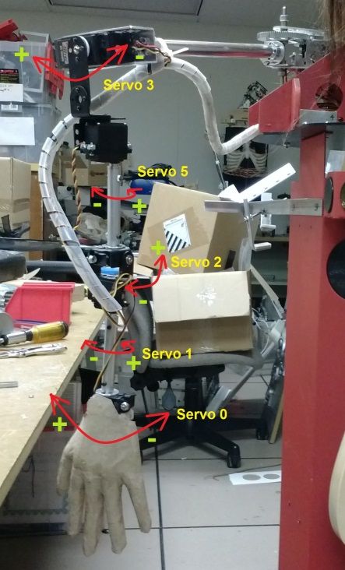 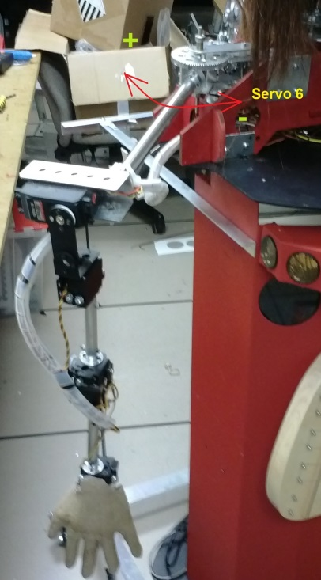

The figure below shows the length measurements of the arm segments between each servo joint.

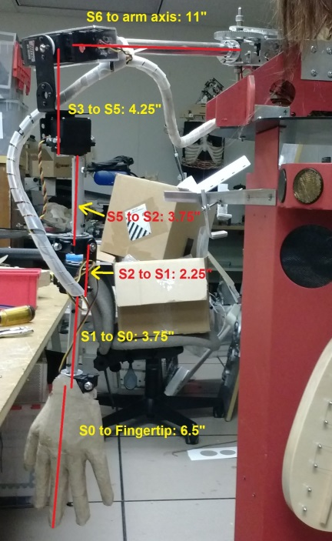

## Servo Replacement and Hardware Documentation

Sixteen servos are used to control the upper body of the Countess Quanta robot. The types of some of these servos are known, while others are not documented and would require disassembly of some portion of the robot to determine their type. Here are the known servos and their type, in case these servos need to be replaced:

Servo 0 (Wrist left/right) – Hitec HS-82MG

Servo 1 (Wrist rotation) – Hitec HS-82MG

Servo 2 (Wrist Up/down) – Hitec HS-82MG

Servo 3 (Arm Up/down) – Hitec HS-705MG

Servo 5 (Arm rotation) – Hitec HS-645MG

Servo 6 (Shoulder left/right) – Futaba S3003

Servo 9 (Head up/down) – Hitec HS-700BB

Servo 10 (Head left/right) – Hitec HS-700BB

Here are some hardware items that remain to be documented:

* Servo types for the remaining eight servos.
* How is power supplied through the robot base into the Maestro servo controller?
* Is the power supply sufficient to move all sixteen servos simultaneously?